**SPIKESmate**

Instruction Manual: Detailed Usage Instructions

**01 – Homepage**

Navigating to the link provided from the PHAR3311 unit webpage will direct the browser to the SPIKESmate website homepage.

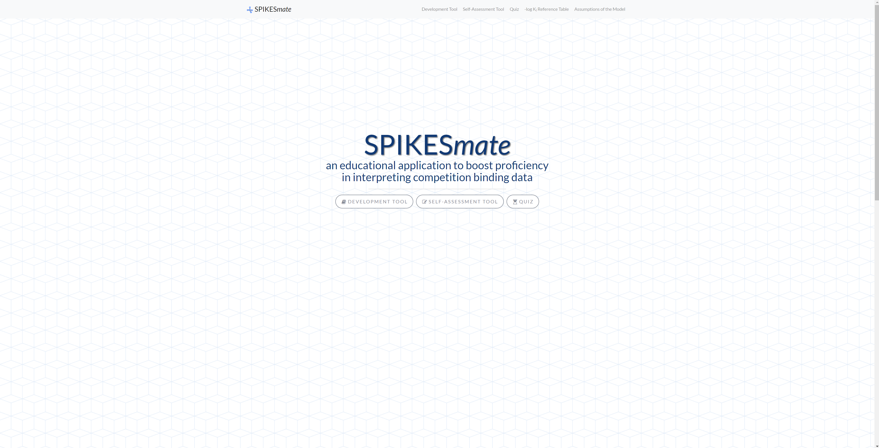

**Static Elements**:

**Text Logo**: ‘SPIKESmate’.

**Text**: ‘An educational application to boost proficiency in interpreting competition binding data’.

**Interactive Elements**:

**A: Homepage Button** - ‘SPIKESmate’.

**B: Menu Button** - ‘≡’.

1. This button will navigate the browser back to the SPIKESmate homepage. This can be clicked from any page in the website and will return the user to the homepage.
2. This button will produce a Sub-Menu of the following 5 buttons:
3. **‘Development Tool’**
4. **‘Self-Assessment Tool’**
5. **‘Quiz’**
6. **‘ Reference Table’**
7. **‘Assumptions of the Model’**
8. This button will navigate to the **Development tool** designed at educating users regarding receptors, densities, ligands, binding, values and associated graphing curves.
9. This button will navigate to the **Self-Assessment tool**. This is like the development tool but with receptors and densities hidden to challenge the user to determine the receptors and densities themselves. The graph co-ordinate values are hidden too. When the user clicks to reveal the answer the receptors and densities are revealed.
10. The **Quiz** is similar to the self-assessment tool but after the user has determined the receptors and densities they enter the values and click submit. The user will then continue through all questions in the quiz until they have submitted an answer to each of the questions after which the results are displayed complete with a score and the correct answers to each question
11. Clicking this button produces a pop-up which features some important data on which the tools are based.

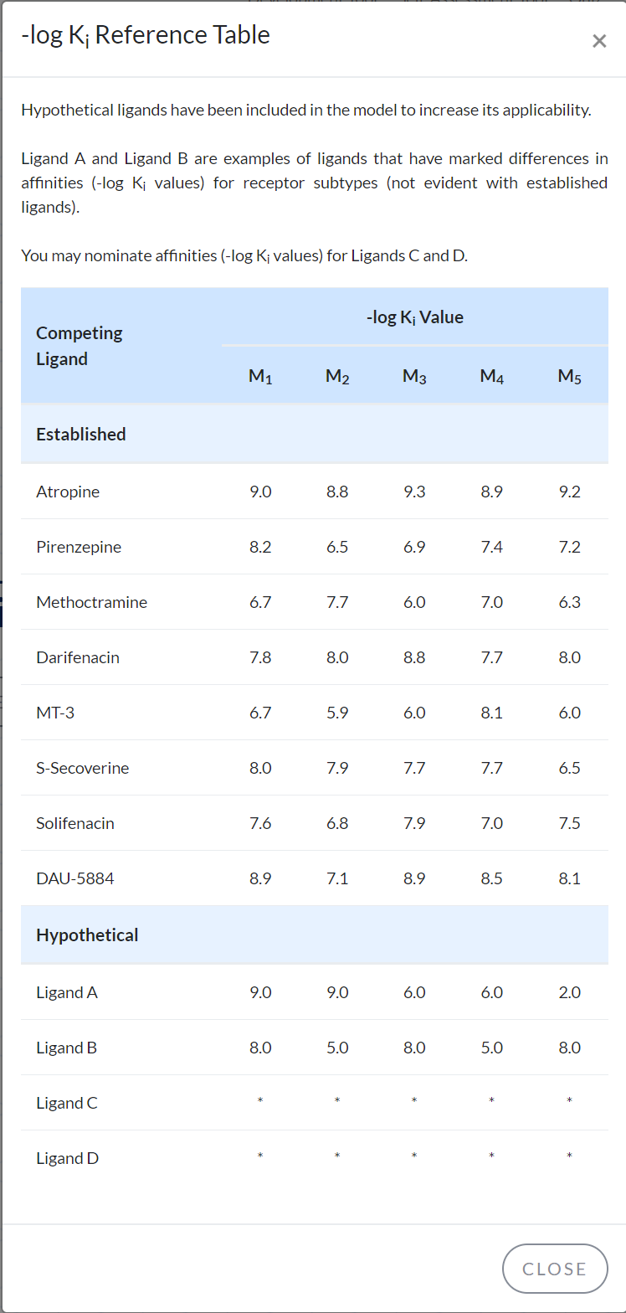

The table includes receptor values for each of the pre-defined ligands as well as two custom ligands which have been specified.

* 1. In order to close the pop-up either click the Black **‘X’** at the top right corner of the table or the **‘CLOSE’** button at the bottom right corner of the table
  2. This will return navigation to the home page with the pop-up window closed

1. Clicking this button will produce a pop-up which can be closed by clicking the black **‘X’** at the top right corner of the pop-up window or by clicking the **‘CLOSE’** button at the bottom right corner of the pop-up window.

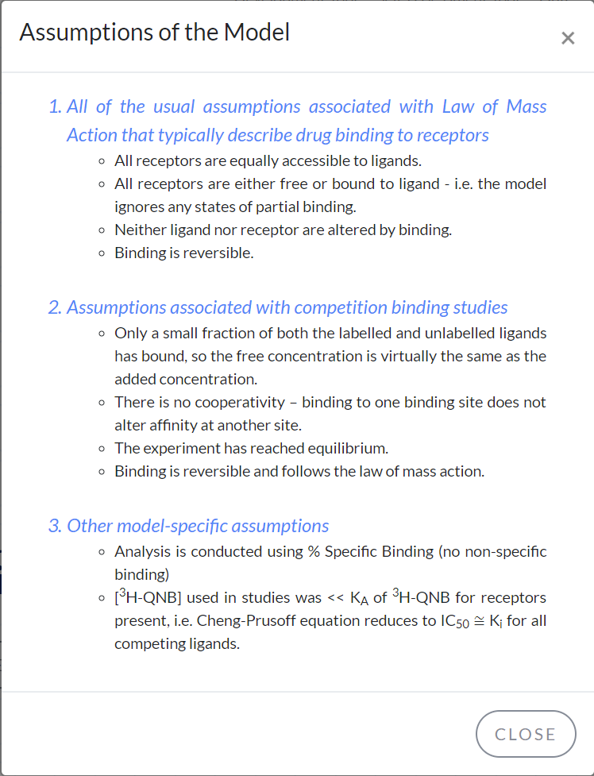

**Headings/ Paragraphs 1, 2 and 3 describe different assumptions:**

* 1. The assumptions in relation to the law of mass action that describes drug binding to receptors.
  2. The second paragraph describes the assumptions associated with competition binding studies
  3. The third paragraph describes the assumptions that are model specific

There are three main pages accessible from the homepage with links appearing below the SPIKESmate title

**C: ‘Development Tool’ Button**

**D: ‘Self-Assessment Tool’ Button**

**E: ‘Quiz’ Button**

1. The **Development tool** button will navigate to the development tool page which is an educational tool designed to map receptors, receptor densities and ligands to curves based on values. The resultant curves are graphed for educational purposes. Graph values can also be revealed by tracing the mouse pointer/ cursor over the curves to determine exact values at a given point on each curve. Of importance is the 50% binding value which corresponds exactly with the provided value for the respective ligand against the selected receptor.
2. The **Self-Assessment tool** is identical to the development tool only that the receptors and their respective densities are hidden. The goal of this tool is for each student to learn to identify receptors and densities based on the selected ligands (including custom ligands) and their graphed curves. Note that in this mode, graph curve values cannot be revealed as this would trivialise the identification of the receptors in question.
3. The **Quiz** is similar to the Self-Assessment tool in that receptors and densities are hidden and that the graph co-ordinate values are not displayed but there are several practice questions which form a quiz that can be attempted by a user. Once an answer has been submitted for all of the questions, results are published including scores and a list of the correct answers.

**F: ‘About’ Button**

**G: ‘Instructions’ Button**

**H: ‘Contact’ Button**

1. This about section pop-up describes the project and it’s key contributors and IP holders. Interactivity is featured in the **‘X’** close button, and **‘CLOSE’** button

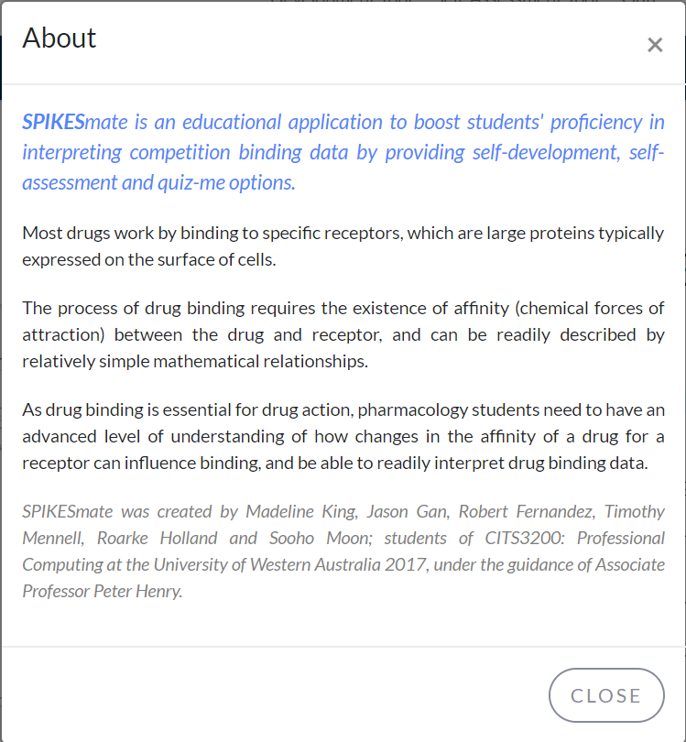

1. Development Tool, Self-Assessment Tool and Quiz instructions appear as well as **‘X’** close, and **‘CLOSE’** button

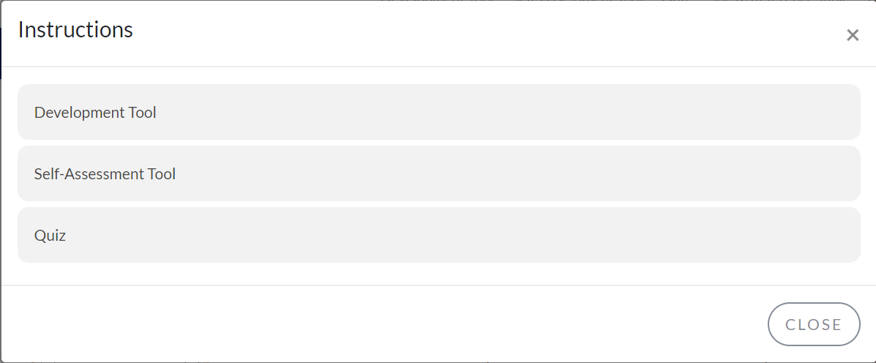

1. Contact details for the unit co-ordinator including title, name and relation to the webpage are listed

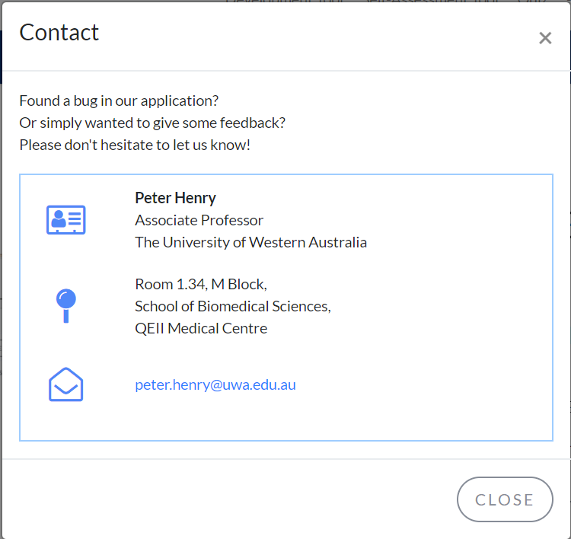

- **Location** for the unit co-ordinator (Physical staff address for Academic Enquiries)

- **Email address** provided

**02 – Development Tool**

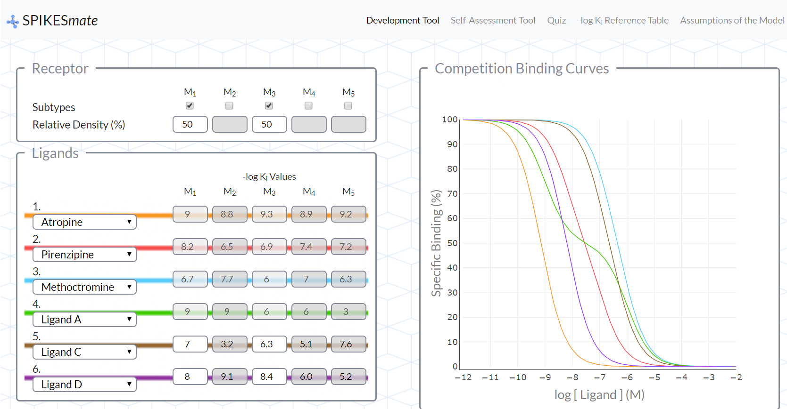

**A: Receptor Module**

1. **Subtypes**

- 1 or 2 or 3 receptors can be selected in total.

- Any given receptor can be selected by clicking on the radio button (A ‘TICK’ is shown in the box) below the required receptor;

- 1, 2 or 3 receptors can be selected at any given time. The application will prevent the user from selecting more than 3 receptors at once.

1. **Relative Density (%)**

Depending on the number of receptors selected, the density can be specified as follows

(Density is always an integer between 1% and 100% inclusive)

**1 Receptor Selected**: Default 100%, 100% (Hard-Coded)

**2 Receptors Selected**: Default 50%, 50%

Total of 100%:

**3 Receptors Selected**: Default 33.3%, 33.3%, 33.3%

Total of 100%:

If three receptor subtypes have been selected, then the combined value must again be 100. In this case, receptor densities should always be entered Left Receptor first. IE This time the left-most active receptor density must be specified first. Once this has been done either of the remaining two densities can be entered and the final density will automatically be calculated. EG if Receptor 1 has density 60% then Receptor 2 is specified as 30% density, Receptor 3 will automatically be given 10% density. Similarly if Receptor 1 has density 50% and Receptor 3 has density 40% then Receptor 2 will automatically be given 10% density. This is how the problem of 2 unknown variables is managed.

**B: Ligands**

Entries 1, 2, 3, 4, 5, 6 are drop down boxes allowing the user to select ligands

- The row of numeric values to the right of each of the drop downs represent the binding values for each of the selected ligands

- Selectable ligands include the 6 established ligands as well as 4 custom ligand types. Whilst the binding values of all 6 established ligands and 2 of the custom ligands are pre-set the 2 free custom ligands require the user to specify the required binding values.

- Based on each of the binding values specified for the custom ligands the number entered will be corrected to be constrained to the domain of numbers permissible by the module. The lowest or minimum legal value is 2 whilst the highest or maximum legal value is 11 so that any user input will produce and populate a number in this field within the domain of real numbers between 2 and 11 inclusive. This legal domain will be enforced for any numeric value entered into the text fields.

- The values for any respective value can be derived from the lookup table accessible from any page on the website through the ‘≡’ button

**C: Competition Binding Curves**

The binding curves provide a graphical representation of the binding curves given the input data for receptors, bindings, ligands and graph range. (typically 2 to 11)

The **Specific Binding %** is specified as the vertical range for the graph along the y axis

The Ligand Values, **-log[Ligand](M)** are specified as the horizontal range for the graph along the x axis

Note that the different colours produced for each curve correspond to the colours associated with each ligand specified in the ligand module.

- The curves can be traced such that the value of the curves at any point can be found by hovering the cursor over them producing a read out of each curve’s value in their respective colours at any point traced on the graph.

- Note that the two options at the top right corner of the graph window allow the user to toggle between displaying co-ordinate data for a single curve or all graphed curves simultaneously

**03 – Self-Assessment Tool**

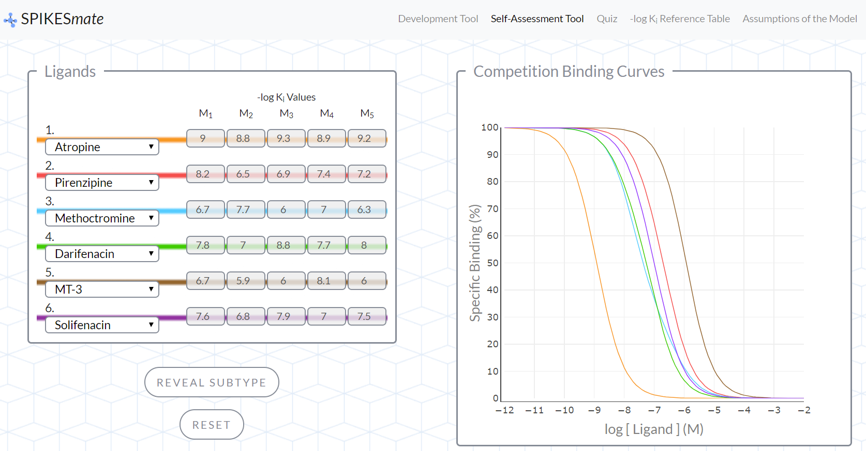

**A: Ligands**

As in section 02 – Development Tool

**B: Interactive Buttons**

**I: ‘Reveal Subtype’**

**II: ‘Reset’**

1. This reveals the hidden receptors and their relative densities
2. This button ‘resets’ the system and randomly generates a new receptor/ density combination

**C) Competition Binding Curves.**

As in section 02 – Development Tool

However the curves cannot be traced in this instance and hovering over the curves will not reveal the X, Y co-ordinate pairs, as this would trivialise the determination of the receptors and their densities.

**04 – Quiz**

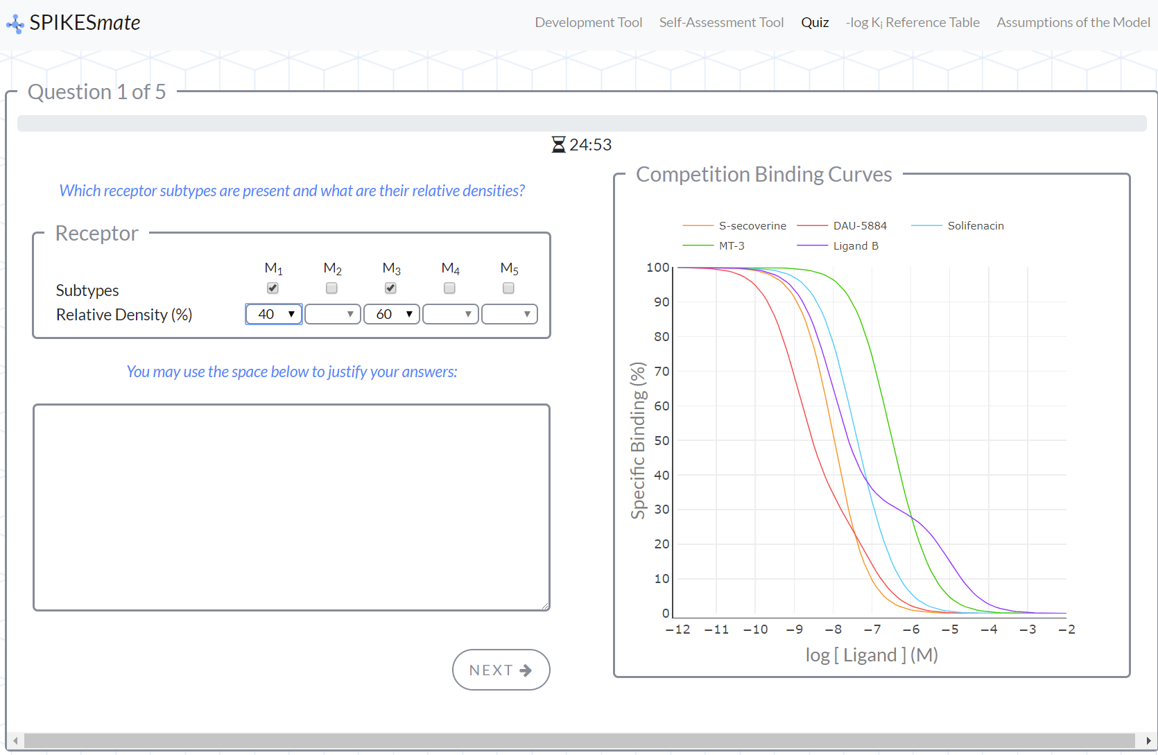

**Quiz Start Page:**

This page describes the quiz, which will follow. Possible answers, marking system and answer entry are all explained. The quiz is both timed and limited to 5 questions.

**START QUIZ**: Will begin the interactive quiz

**A: Receptor Module**

**I) Subtypes**

- Either 1 or 2 receptors can be selected in total.

- Any given receptor can be selected by clicking on the corresponding radio button (A mark is shown in the box) below the required receptor

- 1 or 2 receptors can be selected at any given time. The module will prevent the user from selecting more than 2 receptors.

- Note that only 2 receptors are ever required as the difficulty level associated with having 3 concurrent receptors goes beyond the competency expected of a third year pharmacology student.

**II) Relative Density (%)**

As in section 02 – Development Tool

**B: Ligands**

As in section 02 – Development Tool

**C: Interactive Buttons**

**I: ‘Next Question’**

**II: ‘Submit’**

1. This button submits the entered receptor density combination and records this answer for interpretation later in the results section
2. This button only appears whilst completing the last question. It completes the quiz.

**D: Competition Binding Curves.**

As in section 02 – Development Tool

This time, as no ligand table is provided, a legend is displayed which labels the ligand associated with each line colour. This is essential for determining the correct receptors and their respective densities.

**E: Review**

The review page appears after all quiz questions have been answered.

At the top of the review page is the score determined for the quiz attempted

The table below shows each question number, the answer provided by the user and the correct answer for the given problem.

This enables students to recognise where they have selected the correct answer and where they haven’t and shows them what the correct answer was in the given instance.

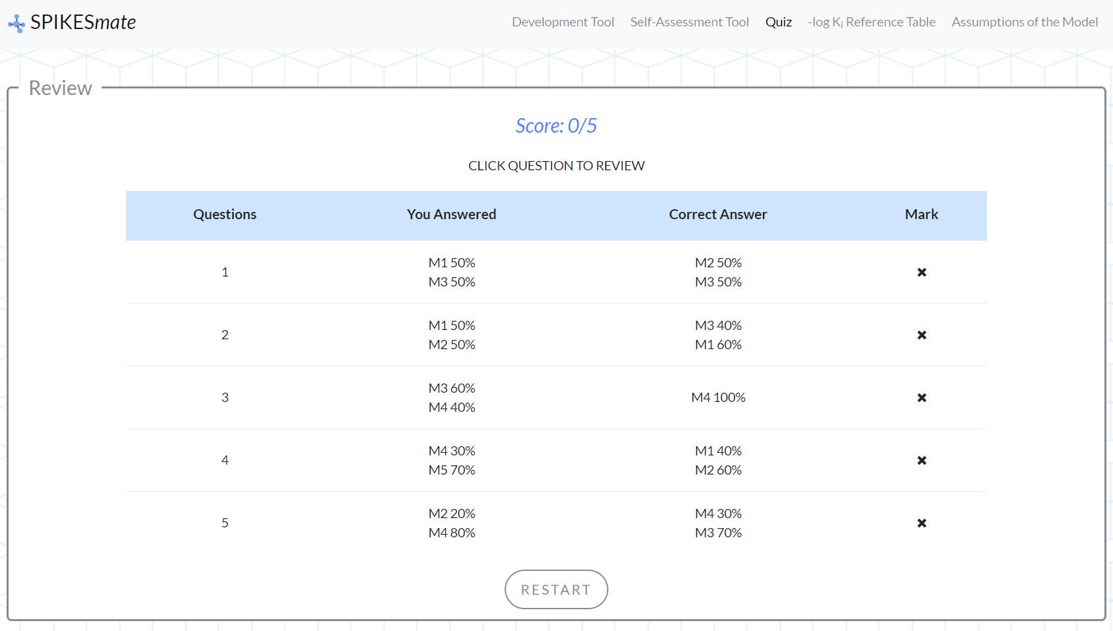

**RESTART**: This resets the quiz